

**Immaculata-La Salle**

**High School**

**Student-Athlete Handbook**

**2019-2020**

**Immaculata-LaSalle High School**

**3601 S. Miami Ave**

**Miami Florida 33133**

**305-854-2334**

[**www.ilsroyals.com**](http://www.ilsroyals.com)

**TABLE OF CONTENTS**

Message to Student Athletes and Parents 1

ILS Athletic Staff 2

Mission Statement 3

Philosophy……… 3

Athletic Department Goals and Objectives 4

Immaculata-La Salle Activities 4

Introduction……… 5

Rules and Regulations 5

Athletic Requirements and Eligibility 6

NCAA Requirements 6

Rules for Athletes 7

Suspensions…….. 8

Dismissal…………. 9

Inventory/Equipment/Uniforms 9

Physician’s Statement 9

School Accident Insurance 9

Injury/Accidents……. 10

Scheduling…………. 10

Athletic Awards……… 10

Fans………………. 11

Parent/Coach Relationship 11

Communication……… 11

Athletic Financial Responsibility 12

Ticket/Admission Information 12

Archdiocese of Miami Policies 13

* + 1. Anti Bullying Policy 13
    2. Child Protective Investigations 14
    3. Conduct 15
    4. Drug and Alcohol Policy 14
    5. Fund Raising 15
    6. Harassment and Discrimination 15
    7. Medications 15
    8. Private Tutoring, Coaching or Lessons 15
    9. Public Display of Affection 15
    10. School-Sponsored Events 16
    11. Search and Seizure 16
    12. Threats of Violence 16
    13. Use of Photos 16
    14. Weapons Policy 16

Required FHSAA Forms 18

Student and Parent Verification and Code Signature Form 25

ILS Concussion Policies 26

A Message to Student Athletes and Parents

*Welcome to Immaculata-La Salle Athletics, home of the Royal Lions!*

*We here at ILS are extremely excited to welcome all students, parents and supporters of the Royal Lions. Athletics are a vital part of our school community and provide a solid foundation for the growth and development of our young men and women. As a school we want to continue to build and grow our student-athletes spiritually, physically and emotionally. We believe that participation in athletics promotes qualities like character, accountability and discipline, as well as working on important virtues like patience, sportsmanship and humility. These reasons, and many more, have been outlined in this handbook to allow us to hold your athletic department in the highest regard in our pursuit of excellence.*

*There are a number of stakeholders involved in the athletic department that aid in the development and operation of a successful program. For ILS student-athletes and coaches to succeed, a certain level of ability and preparation is required. In addition, we expect the student-athletes, coaches and parents to adhere to the rules and regulations outlined in this handbook. Please read and review these policies carefully. We urge all student-athletes and parents to familiarize themselves with the goals and purposes of our Salesian athletic program. Allow us to use athletics the way it was intended: as a teaching tool that allows our student-athletes to create goals, compete, celebrate, and learn to deal with the successes and hardships that follow as a member of the Royal Lion athletic program.*

*Thank you for your support, and welcome to another exciting year of Immaculata-La Salle Athletics! We look forward to all the experiences this year has to offer while we represent our school to the best of our abilities. We are all excited to be a part of a long-lasting tradition of excellence here at Immaculata-La Salle!*

*GO ROYAL LIONS!*

*Many Blessings,*

*Nicholas Fernandez*

*Athletic Director*

*Immaculata-La Salle High School*

**

**ILS Athletic Staff**

**Principal** Sr. Kim Keraitis, FMA [principal@ilsroyals.com](mailto:principal@ilsroyals.com)

Dean of Students Colette Varese [cvarese@ilsroyals.com](mailto:cvarese@ilsroyals.com)

**Athletic Director** Nicholas Fernandez [Nfernandez@ilsroyals.com](mailto:Nfernandez@ilsroyals.com)

**Asst. Athletic Director** Anthony Vuono AVuono@ilsroyals.com

**Asst. Athletic Director** Derrick de La Grana Ddelagrana@ilsroyals.com

**Athletic Trainer** Eddie Cerdeiras [eddie.cerdeiras@ilsroyals.com](mailto:eddie.cerdeiras@ilsroyals.com)

**Athletic Trainer** Camille Wilkerson [Cwilkerson@ilsroyals.com](mailto:Cwilkerson@ilsroyals.com)

**ILS Head Coaching Staff**

**Strength & Conditioning Nathan Gomez** [ngomez@ilsroyals.com](mailto:ngomez@ilsroyals.com)

**Head Football Helder Valle** [Hvalle@ilsroyals.com](mailto:Hvalle@ilsroyals.com)

**Head Boys/Girls Golf James Rydborn** [jrydborn@ilsroyals.com](mailto:jrydborn@ilsroyals.com)

**Head Swimming                Aimee Cerdeiras** [aimee.cerdeiras@ilsroyals.com](mailto:aimee.cerdeiras@ilsroyals.com)

**Head Girls/Boys Volleyball    Luis “Danny” Saladrigas** [saladrigasl@gmail.com](mailto:saladrigasl@gmail.com)

**Head Cheerleading Coral Buxeda** [coralbuxeda@gmail.com](mailto:coralbuxeda@gmail.com)

**Cheerleading Moderator Lexi Quintero** [lquintero@ilsroyals.com](mailto:lquintero@ilsroyals.com)

**Head Cross Country Eddie Cerdeiras** [eddie.cerdeiras@ilsroyals.com](mailto:eddie.cerdeiras@ilsroyals.com)

**Head Girls Basketball Danny Arguello** [Darguello@ilsroyals.com](mailto:Darguello@ilsroyals.com)

**Head Boys Basketball Derrick de la Grana** [ddelagrana@ilsroyals.com](mailto:ddelagrana@ilsroyals.com)

**Head Girls Soccer Anthony Vuono** [avuono@ilsroyals.com](mailto:avuono@ilsroyals.com)

**Head Boys Soccer                  Richard Jobson** [rjobson@ilsroyals.com](mailto:rjobson@ilsroyals.com)

**Head Baseball                        Nathan Gomez** [ngomez@ilsroyals.com](mailto:ngomez@ilsroyals.com)

**Head Softball                         TBD**

**Head Tennis                          James Rydborn** [jrydborn@ilsroyals.com](mailto:jrydborn@ilsroyals.com)

**Head Track                            Aimee Cerdeiras** [aimee.cerdeiras@ilsroyals.com](mailto:aimee.cerdeiras@ilsroyals.com)

**Head Lacrosse                       TBD**

**Dance Moderator                  Dennise De Arce** [Ddearce@ilsroyals.com](mailto:Ddearce@ilsroyals.com)

**Athletic**

**Mission Statement**

Immaculata-La Salle High School athletic department will create and foster an environment that provides opportunities for the student-athletes to enrich their high school experience through participation on athletic teams.

We are dedicated to providing opportunities which will enhance the intellectual, physical, social, moral, and spiritual development of the whole person, while conducting all activities with honesty and integrity in accordance with the principles of good sportsmanship and ethical conduct which embody the Salesian System of Education, preparing our student- athletes for a lifelong commitment to Faith, education, leadership and service.



**Philosophy**

Immaculata-LaSalle High School will field competitive athletic teams in all interscholastic sports in which it participates. Student athletes and coaches are expected to participate in these programs with the Christian principles and practices espoused by the school. It is our firm belief that success will be achieved under this philosophy, and that the achievements and recognition brought to the school and the athletic department will have longer lasting value when accomplished in conjunction with our Christian values.

WE BELIEVE: Interscholastic athletics are an integral part of a school’s curriculum.

WE BELIEVE: Participation in a wide variety of interscholastic sports programs contributes positively toward the development of a young person’s health, physical ability, social competence and discipline.

WE BELIEVE: In providing a well-balance and organized program of interscholastic athletics for girls and for boys, and in managing and operating this program within the guidelines and policies of The Archdiocese of Miami and Florida High School Association (FHSAA).

**ATHLETIC DEPARTMENT**

**GOALS AND OBJECTIVES**

* Spiritual
  + To develop young men and women to be good Catholic/Christians Ambassadors in all their endeavors by achieving excellence through virtues.
* Physical
  + To provide our student athletes with guidelines and assistance in developing athletic/academic success.
* Mental
  + To develop a well-rounded individual by teaching the importance of practice and preparation in reaching the student athlete’s potential.
* Social
  + To provide, through competition, for the emergence of a strong self-concept by developing strong character, leadership qualities, and good citizenship, along with the student athlete’s physical qualities.
  + To develop an equitable athletic program as it applies to "gender equity" in high school athletics.
* Educational
  + To promote teamwork, self-discipline, dedication, commitment, and perseverance.

**"Nurturing mind, body, and spirit through academic and athletic achievement."**

**IMMACULATA - LA SALLE ACTIVITIES**

Immaculata-LaSalle interscholastic athletic program is a member of the Florida High School Athletic Association (FHSAA), which involves competition with other public and private schools.

Presently, Immaculata-LaSalle recognizes field teams in the following interscholastic activities:

**FALL:**

Varsity Football Boys

JV Football Boys

Varsity Cross Country Boys & Girls

Varsity Golf Boys & Girls

Varsity Swimming Boys & Girls

Varsity Volleyball Girls

JV Volleyball Girls

**WINTER:**

Varsity Basketball Boys & Girls

JV Basketball Boys & Girls

Varsity Soccer Boys & Girls

JV Soccer Boys

**SPRING:**

Varsity Baseball Boys

JV Baseball Boys

Varsity Lacrosse Boys

Varsity Softball Girls

Varsity Tennis Boys & Girls

Varsity Track & Field Boys & Girls

Varsity Volleyball Boys & Girls

**YEAR ROUND:**

Cheerleading Girls

Dance Team Girls

**INTRODUCTION**

Interscholastic athletes can be fun, rewarding, and memorable part of the high school experience. While academics offer the primary source for formal education, athletics can contribute to the total value of that education in many different ways. Building upon the concepts of teamwork, fair play, sportsmanship, and self-esteem, athletics can help to provide for a well-rounded educational experience.

Athletic participation is a privilege and not a right. To those who strive to succeed in the classroom comes the privilege to compete outside of it.

Being an athlete, or the parent of an athlete, is often a very challenging task. Sometimes this relationship can become complicated by the nature and structure of athletics in general. It is the intent of this Athletic Handbook to provide some insights into the role and responsibilities athletes and parents face and share, separately and together, in the realm of high school athletic participation.

The high school sports experience is much different than the recreational sport experience. Whereas recreational sport philosophy stresses equal participation by all, at the interscholastic level playing time is earned and not guaranteed.

Student-athletes earn playing time through good work ethics in practice, skill development, sportsmanship, and overall team attitude. Likewise, not all who try out for a given team will endure through the final selection process to make the team roster. Coaches are responsible for the selection of team rosters and for the determination of playing time for those on the team.

**RULES AND REGULATIONS**

**Athletic Participation**

1. Twelfth graders may participate at the varsity level only. Exceptions to this rule will be approved by the Athletic Director.
2. Eleventh graders should participate at the varsity level, but may participate on junior varsity teams.
3. Tenth graders may participate at the junior varsity level, but may participate at the varsity level.

4. Ninth graders should participate at the ninth grade/JV level if it is offered, but are eligible to move up to varsity.

5. Student athletes have four consecutive years of eligibility starting when they first enter ninth grade.

6. If a student quits a sport before the season is over, he/she is **NOT** allowed to participate in another sport until that sport's season is completed, unless the coaches and Athletic Director agree to let a student start another sport.

**ATHLETIC REQUIREMENTS AND ELIGIBILITY**

State law, the regulation of the FHSAA, governs eligibility rules and policy established by the Administration of Immaculata-LaSalle High School. All required forms are available in the ILS office, on the ILS website, [www.ilsroyals.com](http://www.ilsroyals.com/) and the FHSAA website, [www.fhsaa.org.](http://www.fhsaa.org/) In order for an athlete to be eligible:

1. The FHSAA requires all student athletes must show proof of health insurance. School insurance and Medicaid are acceptable in meeting this requirement.
2. A student may participate in interscholastic athletic competition until reaching the age of 19, unless his/her birthday is after September 1 of their Senior Year. Upon reaching the age of 19 prior to September 1 of their Senior year, the student becomes ineligible to compete in interscholastic sports.
3. A high school student will have four years of consecutive eligibility. If the four years of eligibility expires while a student is still in season, he/she will be allowed to complete their sport’s season, but will not be eligible for the next sport season.
4. According to school policy, a student must pass at least six (6) subjects in a marking period, and maintain a GPA of at least a 2.0 on a 4.0 **unweighted** scale for the semester in order to be eligible to participate in athletics for the next semester. ILS personnel will monitor 1st quarter grades, 1st semester grades and the finals grade for purposes of determining eligibility. If a student falls to a 2.5 or lower unweighted GPA at any point during a marking period, a weekly progress report will be issued to the student; the student is to have it filled out on Friday and turn it in to his/her coach as soon as possible.
5. A student must have a yearly FHSAA physical form documented by a Florida doctor before he/she can participate in a sport. All students must have a signed Parent Consent form and Consent Certificate for Concussion and Heat Related Illness form on file with the athletic office.
6. All students must have signed Student/Parent Verification form before participating in a sport at Immaculata-LaSalle.
7. Transfer students **may be** allowed to participate in athletic competition under certain circumstances set forth by the FHSAA. Notification needs to be made to the Athletic Director before arrangements are made to apply for transfer eligibility. Transfer student may not participate in any way on any team until cleared by the FHSAA and notified by the athletic office.

*\*\*An athlete who falsifies information to gain eligibility status that causes a member school to violate eligibility rules shall be declared ineligible to represent any member school for a period of one year from the date of discovery of the violation.*

**NCAA Requirements**

The high-school student-athlete must meet the following standards as passed by the NCAA in January 1983 and subsequently updated to be eligible for college participation. Immaculata-LaSalle High School follows the directives of the NCAA and is not responsible for any requirement changes made by the NCAA. Please refer to the NCAA for the latest updates at www.ncaa.org.

The student-athlete must:

1. Earn a minimum grade point average of 2.3 in the core-curriculum as defined by the NCAA

2. Earn a minimum of 900 combined score on the SAT (verbal and mathematics sections)

3. Student-Athletes are advised to take the SAT or ACT in their junior year

4. Register in the College Clearing House by the end of Junior year through his/her guidance counselor.

**RULES FOR ATHLETES**

Student athletes are representatives of the school, and should conduct themselves accordingly on and off the playing field. All athletes are expected to adhere to the following general and specific rules:

**General Rules**

1. Conduct yourselves as ladies and gentlemen. Set an example for the rest of the student body.
2. **The use of alcohol, tobacco, or illegal drugs is strictly prohibited and could result in removal from the team.**
3. All student athletes will dress appropriately for their sport. The individual uniform will be specified in the description of each sport. Appropriate footwear must be worn in every sport dependent upon the playing surface.
4. Never use profanity.
5. Attend all practices and contests unless excused by the coach.
6. Complete the season.
7. Attend school regularly.
8. Respect school property.
9. All equipment issued should be returned in the same condition. Students and their parent/guardian are responsible for lost or damaged uniforms and other equipment.
10. Display good sportsmanship at all times.
11. **Do not involve himself/herself in any form of gambling.**
12. Always show respect toward the administration and faculty of ILS, the officials and opponents, as well as the community in general.
13. Follow all school rules at all times.

**Specific Rules**

1. Attendance at all scheduled practices and games/meets/tournaments are mandatory, unless excused by the head coach. An athlete must have an acceptable reason and/or prearranged absence such as illness, deficiencies in schoolwork or other obligations not reasonably anticipated by the athlete. Unexcused absences from practice or competition may lead to disciplinary measure to be determined by the head coach.

2. Any athlete who quits a team will not be permitted to play on another team until the end of the season of the team he/she has quit. The Athletic Director may make exceptions for special cases.

3. On days school is in session, an athlete must attend the last four periods of the day in order to participate in a game or practice.

4. For a Saturday game, the student must be in class on Friday for the last four periods of the day.

5. An athlete suspended in or out of school is automatically suspended from the team. The athlete cannot participate in a game or practice until the suspension is over, and he/she has been reinstated by the school administration

6. If a student is suspended or dismissed from a team for disciplinary reasons, he/she is ineligible to participate in **any** sport unless granted permission by the Athletic Director. The coach will immediately notify the Athletic Director of any suspension.

7. An athlete may participate simultaneously on more than one team provided all coaches concerned and the Athletic Director grant permission. It will be the duty of the coaches concerned and the Athletic Director to arrange a schedule acceptable to the athlete and coaches to insure that the athlete is not "caught in the middle between two coaches.” **PARTICIPATING ON TWO TEAMS SIMULTANEOUSLY IS NOT ENCOURAGED.**

8. Any athlete assigned detention by any teacher or administrator must report to that detention. Detention **takes precedence over team practice or games.**

**SUSPENSIONS**

1. A one game suspension by the coach for disciplinary reasons may be implemented, provided the Principal and Athletic Director are notified. The A.D. must be notified of any suspension the day they are implemented and reserves the right to further impose additional suspension time should such infractions of the student athlete reflect negatively on the Immaculata-LaSalle High School program or any after school events

2. The Athletic Director and the Administration reserves the right to impose suspensions for inappropriate actions by a student athlete before, during and after events that reflect negatively on the Immaculata-LaSalle High School athletic program. The suspension can include school and athletic time

3. Players ejected during a contest by an official may not participate for the next seven days or a minimum of two contests. Players ejected with gross unsportsmanlike conduct will be suspended from athletics for six weeks or more.

**Specific Rules**

1. Attendance at all scheduled practices and games/meets/tournaments are mandatory, unless excused by the head coach. An athlete must have an acceptable reason and/or prearranged absence such as illness, deficiencies in schoolwork or other obligations not reasonably anticipated by the athlete. Unexcused absences from practice or competition may lead to disciplinary measure to be determined by the head coach.

2. Any athlete who quits a team will not be permitted to play on another team until the end of the season of the team he/she has quit. The Athletic Director may make exceptions for special cases.

3. On days school is in session, an athlete must attend the last four periods of the day in order to participate in a game or practice.

4. For a Saturday game, the student must be in class on Friday for the last four periods of the day.

5. An athlete suspended in or out of school is automatically suspended from the team. The athlete cannot participate in a game or practice until the suspension is over, and he/she has been reinstated by the school administration

6. If a student is suspended or dismissed from a team for disciplinary reasons, he/she is ineligible to participate in **any** sport unless granted permission by the Athletic Director. The coach will immediately notify the Athletic Director of any suspension.

7. An athlete may participate simultaneously on more than one team provided all coaches concerned and the Athletic Director grant permission. It will be the duty of the coaches concerned and the Athletic Director to arrange a schedule acceptable to the athlete and coaches to insure that the athlete is not "caught in the middle between two coaches.” **PARTICIPATING ON TWO TEAMS SIMULTANEOUSLY IS NOT ENCOURAGED.**

8. Any athlete assigned detention by any teacher or administrator must report to that detention. Detention **takes precedence over team practice or games.**

**DISMISSAL**

When the behavior of an athlete is deemed inappropriate, it may be necessary to dismiss that individual from the team. Before dismissal of an athlete, the Principal, Coach, and Athletic Director shall review the case. Parents will be given the opportunity to review the cause for dismissal.

**INVENTORY/EQUIPMENT/UNIFORMS**

1. Each coach is responsible for all athletic property issued to him/her, each athlete is also responsible for all athlete equipment and uniforms issued to them by their coach. At the completion of the season, an inventory form should be completed and returned to the Athletic Director. The coach will list all property, its condition, storage area, and replacement needs. Nothing new will be ordered until inventory is complete. It is imperative that coaches and members of their teams pay strict attention to manufacturer's instructions on washing and care of uniforms.
2. The coach will notify the Athletic Department of equipment and/or uniform that is not turned in by an athlete. That athlete and their parent/guardian is responsible for the replacement of that equipment and/or uniform, and can be held financially responsible for the failure to turn in said equipment and/or uniform. The replacement fee for any damaged or lost athletic equipment and/or uniforms will be the amount of the original purchase price.

**PHYSICIAN'S STATEMENT**

**NO** student shall be eligible to represent Immaculata-La Salle High School in interscholastic athletics unless there is on file a physician’s statement for the current year certifying that the student has passed an adequate physical examination and that in the opinion of the examining physician the student is fully able to participate in high school athletics. Parents are required to sign FHSAA form releasing student athletes for participation in athletics. This form will and must accompany the required health form.

**SCHOOL ACCIDENT INSURANCE**

Immaculata-LaSalle carries an accident insurance policy to cover injuries or accidents which occur during school time or during participation in school sponsored and supervised activities. Benefits are subject to the terms, conditions and limitations of the insurance policy. School insurance may not cover 100% of the total expenses and all claims must be filed ***within 60 days of the date of the last treatment.*** Benefits will be paid to cover the usual and reasonable medical expenses which are incurred within the Maximum Accrual Period.

The school provides the needed insurance forms; however, parents are reminded that ***the school does not follow up with the insurance. It is the parent's/guardian's responsibility to communicate directly with the insurance company.***

**INJURY/ACCIDENTS**

ALL injuries or accidents occurring during a game, practice, P.E. class and/or outside the school curriculum, whether recreational or club sports related, MUST be reported to the Athletic Trainer and the administration immediately. An **accident report MUST** be filled out in the Athletic Office immediately.

Any student who is participating in varsity sports MUST notify the Athletic Trainer of any history related to CONCUSSIONS (symptoms following a blow to the face/head), preexisting illnesses (mononucleosis, cardiac etc.) and/or any other orthopedic issues, prior to the first day of practice. All Concussion injures MUST follow the ILS CONCUSSION POLICY as written in the manual

Any injuries that have been evaluated by a medical physician, whether an ILS referred physician, personal family physician or an Emergency Care physician must have a written signed release form with the diagnosis of the injury, to be allowed to return to play.

The Athletic Training staff will always have the final say whether a student/athlete can return to participate in sports following an injury. This decision is always made in conjunction with the Athletic Trainer, parents, physician, coaches and student athlete.

**SCHEDULING**

1. The Athletic Director, with the help of the head coach, will make all season schedules.
2. The number of games scheduled must conform to FHSAA standards.
3. Games which require long trips or overnight stay(s) should be considered carefully. Approval is required by the Athletic Director.

4. Overnight stay(s) during the regular season will be paid by the individual team. Immaculata-La Salle High School will pay the overnight hotel expenses for ILS athletes participating in post season play, i.e., District, Regional, State.

1. Parents wishing to attend any overnight event are responsible for their own accommodations.

6. The Athletic Director must approve all schedules.

**ATHLETIC AWARDS**

At the end of the academic year each team will represented at the Team Awards Ceremony, with the coach being responsible for nominating the Most Valuable Player, Coach's and Most Improved awards for the individual sports. Not all teams need to nominate awards they can chose to be represented differently.

Varsity letters are awarded to students who exemplify sportsmanlike conduct (FHSAA bylaws #19-17-1), complete the full season, and compete in at least more than half of the total games/meets of the season. This includes tournament play.

Major year awards as well as Scholar-Athlete, Athlete of the year, and Leadership awards will be presented as part of the Academic/Athletic Awards Ceremony each May.

**FA NS**

Immaculata-LaSalle fans, like ILS student athletes, are a proud group of individuals and are fiercely competitive. An outpouring of fans generates a great deal of excitement and energy felt by the participating student athletes. Coaches, student athletes, and fans rate the “fan-factor” as integral to the success of their teams.

At ILS, positive cheering is employed. “Positive cheering” is defined as yelling, screaming, shouting, clapping, etc. as enthusiastically as you wish for our team. **Negative comments or actions will not be tolerated against our guests** (otherwise known as opponents). **The use of artificial noisemakers shall be prohibited.** We want to be hospitable and also help our teams to win. Failure to abide by these rules may lead to removal from the area of competition immediately.

Game officials are individuals charged with enforcing the rules and maintaining control of the game. They are to be extended every courtesy and respect by team players, coaches and fans. Any interference with game play in a derogatory manner through verbal or physical contact with a game official, coach, or student-athlete may lead to removal from the area of competition immediately. Please understand that ILS depends on a high degree of fan participation on the part of its student body, alumni, parents, faculty, and staff. It is this loyal support that promotes excellence and brings championships. With the help of fans, the proud athletic tradition of Immaculata-La Salle will continue to flourish.

**PARENT/COACH RELATIONSHIP**

Both parenting and coaching are extremely difficult vocations. By establishing an understanding of each position, we are better able to accept the actions of the other and provide great benefit to the student athlete.

As parents, when your child(ren) become involved in the school’s athletic program, you have a right to understand what expectations are placed on your child. This begins with clear communication from the coach of your child’s chosen athletic program.

As your child(ren) becomes involved in the programs available at Immaculata-LaSalle High School, they will experience some of the most rewarding moments of their lives. It is important to understand that there may also be times when things do not go the way you or your child wishes. At these times, a calm, rational discussion with the coach is encouraged.

**COMMUNICATION**

**Coach to Parent**

1. Team rules and the philosophy of the coach.
2. Expectations the coach has for your child as well as all the players on the team.
3. Locations and times of all practices and contests. Scheduled games are subject to change.
4. Team requirements, i.e., fundraising, special equipment, off-season conditioning.
5. Procedures that are followed should your child be injured during participation.
6. Transportation: All school regulations are applicable in situations where students are using transportation provided by a school.
   1. If you wish to take your child from an athletic event not on campus or send your child with another parent, please email head coach or athletic director. [Nfernandez@ilsroyals.com](mailto:Nfernandez@ilsroyals.com) or Assistant A.D [Avuono@ilsroyals.com](mailto:Avuono@ilsroyals.com) or [Ddelagrana@ilsroyals.com](mailto:Ddelagrana@ilsroyals.com)

**Parent to Coach**

1. The development of your child mentally and physically.
2. Ways to help your child improve.

3. Concerns about your child’s behavior.

**Inappropriate Concerns to Discuss with Coaches**

1. Playing time.
2. Team strategy.
3. Play calling.

4. Other student athletes.

**Procedure to Discuss Concerns**

1. Call the Athletic Director to set up an appointment with the coach. A time convenient for the coach, Athletic Director and parent(s) will be determined. The meeting will take place at an agreed-upon location.

2. Do not attempt to confront the coach before or after a practice or contest. These can be emotional times for both the parent and the coach. Meetings of this nature do not promote resolution. A 24-hour cooling off period is advised.

**Athletic Financial Responsibilities**

As with anything of value, there are financial responsibilities for the ILS Student-Athlete and Parent. It is expected that all team packages, team gear (outside of required gear for each sport) and extras will be covered through the club accounts of each team. These Club accounts are outside the school athletic budget and are managed by the Coach and Athletic Director within the system of ILS Financial Offices. Parents and Student-athletes are required to participate in the fundraising efforts of each team in order to offset the many expenses of each athletic team.

Included in these Athletic Financial Responsibilities will be a **$250.00** Student-Athlete Fee which will be charged to the Parents’ account upon the Student-Athlete’s acceptance to the team after tryouts. This will be a one-time fee per Student-Athlete; if he/she plays more than one sport, there will NOT be reoccurring fees per sport. **This one-time yearly fee is expected to be paid to the Financial Office prior to the first athletic competition of the season.**

**Ticket/Admission Information**

**(subject to change)**

***ILS HOME Athletic Events Gate Charge:***

**Varsity Sports Games**

ILS Students No Charge - ILS ID must be presented at gate

Adults $5.00

Other Students $5.00

**Junior Varsity Sports Games**

ILS Students No Charge - ILS ID must be presented at gate

Adults $5.00

Other Students $5.00

***POST SEASON (District, Regional) Gate Charge:***

FHSAA sets admission price for all post season events. All entrants, including ILS students, must pay the entry fee set by the FHSAA.

A Concession stand is available for most athletic competitions.

**Archdioceses of Miami Policies**

**Anti-Bullying Policy:** The school is committed to promoting a safe, healthy, caring, and respectful learning environment for all of its students. As such, bullying is strictly prohibited and will not be tolerated. Therefore, this policy prohibits any unwelcome verbal or written conduct or gestures directed at a student by another student that has the effect of:

(1) physically, emotionally, or mentally harming a student;

(2) damaging, extorting or taking a student’s personal property;

(3) placing a student in reasonable fear of emotional or mental harm;

(4) placing a student in reasonable fear of damage to or loss of personal property; or

(5) creating an intimidating or hostile environment that substantially interferes with a student’s educational opportunities or the Catholic mission of the school.

1. Definition

a. **Bullying** is the willful and repeated harm inflicted upon another individual which may involve but is not limited to: teasing, name-calling, slurs, rumors, jokes, false accusations, intimidation, stalking, innuendos, demeaning comments, pranks, social isolation, gestures, cyber-bullying or other verbal or written conduct. Cyber-bullying includes the following misuses of digital technology: teasing, intimidating, or making false accusations about another student by way of any technological tool, such as sending or posting inappropriate email messages, instant messages, text messages, digital images or website postings (including blogs and social network sites). Bullying reflects a pattern of behavior, not a single isolated incident.

b. This definition includes students who either directly engage in an act of bullying or who, by their behavior, support another student’s act of bullying.

2. Scope

a. This policy prohibits bullying that occurs either:

i. on school premises before, during, or after school hours;

ii. on any bus or vehicle as part of any school activity; or

iii. during any school function, extracurricular activity or other school-sponsored event or activity.

3. Reporting Complaints

a. Each student and parent has a duty to report any bullying to the school immediately. If a student experiences (or a parent witnesses or learns of) any incident of bullying, the incident must be promptly reported to the school principal. The principal will provide the student/parent with the Bullying Complaint Report Form which must be completed, dated and signed by the complaining party so that the school may initiate further inquiry, when appropriate.

4. Disciplinary Action

a. Any student found to have violated this policy may be subject to appropriate disciplinary action, which may include: temporary removal from the classroom, loss of privileges, detention, counseling, parent conference, suspension, expulsion, and/or notification to appropriate authorities. The disciplinary action may be unique to the individual incident and may vary in method and severity based on the principal’s discretion.

False reports or accusations of bullying also constitute a violation of this policy and may subject the offending party to appropriate remedial action which may include, but is not limited to, the assessment of costs incurred by the School in its investigation and review of any reports deemed to have been made in bad faith.

**Child Protective Investigations**: Florida law provides that any person who knows or has reasonable cause to suspect that a child is abused by a parent, legal custodian, caregiver or other person responsible for the child’s welfare must report such knowledge to the Department of Children and Families (DCF). The school will cooperate with all child protective investigations by DCF or the local law enforcement agency. Reports should be made to Florida’s Department of Children and Families by calling the Abuse Hotline at: 1-800-96-ABUSE (1-800-962-2873).

Child protective investigations by DCF or local law enforcement agencies sometimes include interviews of students at school and may occur without advance notice. When it is reasonably possible, the school will seek to notify the parents that their child has been asked to participate in a child protective investigation. The school may also request the presence of a school staff member during investigative interviews on school property. However, please note that, under Florida law, DCF and local law enforcement have the discretion to conduct unannounced interviews and to disallow school staff member’s presence during these interviews.

**Conduct**: Students and Parents are expected to behave consistent with the mission, philosophy and spirit of the school and the moral teachings of the Catholic faith as determined by the Archbishop of the Archdiocese of Miami. Because the school cannot anticipate all conduct that violates this policy, it reserves the right to take any form of (1) student disciplinary action, including expulsion, and/or (2) restrictions against any behavior that violates this policy, even if not specifically stated in this handbook.

**Drug and Alcohol Policy**: The use or possession of illegal drugs or illegal mood-altering substances, alcoholic beverages, drug-related paraphernalia, or the abuse of prescription or over-the-counter drugs by any student on school property or while attending or participating in any school-sponsored activity or at any time the student is wearing a school uniform is forbidden. Transgression of this rule will result in disciplinary action, which may include expulsion from the school, even for a first offense.

Any student selling drugs on school property or at school functions may be immediately expelled.

The school is committed to a drug-free environment. This commitment may, under some circumstances, prompt a need for testing of students for evidence of substance abuse.

If a student exhibits the symptoms, or is suspected of substance abuse, the school may require that the student undergo substance abuse testing at the parents’ expense. If the results of the test suggest abuse (and the substance was not used on or brought to campus or a school-related activity), the school will normally use this information to help the student seek assistance. Refusal to participate in such a test may result in expulsion from the school.

At times, the school may choose to conduct random drug testing of the student body at the parents’ expense. While this measure may not often be implemented, given the seriousness of substance abuse, the administration may consider it an effective and justifiable way of combating the problem.

A school may conduct random searches as set forth in this handbook.

Electronic Acknowledgments: Periodically, the school may require that parents or guardians make electronic acknowledgments confirming the receipt and/or acceptance of various policies, procedures, notices, releases or updates. Any time a parent/guardian makes an electronic acknowledgment by clicking “submit” or “accept” on an electronic document, that individual is agreeing that he/she has read, understood, and agrees to be bound by the contents of the electronic document. Electronic acknowledgments and signatures are valid and binding and may serve as consent to the contents of any electronic communication. Parents and guardians are responsible for reviewing the contents of any electronic document prior to making any electronic acknowledgments. In addition, Parents/Guardians, by executing the acknowledgement of receipt of this Handbook, HEREBY AGREE to receive and be bound by electronic acknowledgments.

**Fundraising**: No student may solicit funds in the school’s name unless such solicitation has been authorized in writing by the principal.

**Harassment and Discrimination**: The school is committed to providing an environment that is free of discrimination and harassment. In keeping with this commitment, the school will not tolerate harassment or discrimination on the basis of a person’s protected status, such as gender, color, race, ancestry, national origin, age, physical disability, mental condition, marital status, veteran status, citizenship status. All employees, faculty members and students are protected under this policy. In addition, this policy applies to all conduct occurring on school grounds, at assignments outside the school, or at school-sponsored events. All students are responsible for helping to assure that any harassment or discrimination is reported. If a student witnesses or learns of any conduct that violates this policy, the student must immediately report the incident to his/her principal. If, however, the principal is the individual who is believed to have engaged in the inappropriate conduct, the student should notify the Superintendent of Schools of the Archdiocese of Miami. If an investigation reveals that inappropriate conduct has occurred, the school will take corrective action based on the circumstances.

**Medications**:Students are not permitted to carry or distribute any prescription or non-prescription drugs or treatments, including aspirin, on the school grounds or at any school function. The administering of medicine to a student outside the doctor’s office or a health institution is a parental responsibility and should not be delegated to school personnel except under unusual circumstances. Parents should ask their physicians if it is possible to prescribe medication so it can be administered at home. Only when necessary will the school allow the administration of medication on campus, and only under the following guidelines:

1. An “Authorization for Medication” form must be completed and submitted by a parent or legal guardian of the student. The name of the medication and dosage should be indicated on the form.

2. Medications to be taken by students must be personally brought by the parent or legal guardian to the School Office. Medications to be dispensed at school must be labeled with the child’s name and the exact dosage. The name and telephone number of the physician should also be on the label. Students may not bring the medication to school alone.

3. If a student must take any medication during the school day, the medication must be kept with the Nurse or School Office and the student must go there to take it.

4. While the school will monitor a student taking the medication, the school will not remind students to come and take their medication.

Exceptions to this policy may also be made for the use, supply and administration of an epinephrine auto-injection (Epi-pen).

**Private Tutoring, Coaching or Lessons**: Except as specifically noted in this Handbook, the school does not sponsor, oversee, or otherwise provide private tutoring, coaching, therapy or other similar private lessons or services. Parents who engage school staff members for the provision of these services do so at their own risk and expense and are hereby advised that such services are outside the scope of the staff member’s employment with the school. **Parents, by executing the acknowledgment of receipt of this Handbook HEREBY RELEASE the school, the Archdiocese, and their corporate members, officers, employees, affiliates, and agents from any claims or liabilities that allegedly arise from or are related to the provision of private tutoring, coaching, therapy or other similar private lessons or services, regardless of where they may occur.**

**Public Display of Affection**: The Catholic school promotes friendship, charity, kindness, love and respect for self and others. However, inappropriate displays of affection, such as kissing or embracing which connote more than simple friendship, are not permitted in school, at school dances, or at any school event. Those who violate these rules may be subject to disciplinary measures, including detention, suspension or expulsion. The administration reserves the right to determine what is, or is not, appropriate behavior in a Catholic school.

**School-Sponsored Events**: The school does not sponsor, oversee, or in any way control parties or social functions at private residences. School-sanctioned events, including all field trips, excursions, or parties, are specifically identified in this Handbook or are identified in the school calendar and/or written notices generated and distributed by the school.

**Parents, by executing the acknowledgment of receipt of this Handbook, hereby release the school, the Archdiocese of Miami, and their corporate members, officers, employees, affiliates, and agents, from any claims or liabilities that allegedly arise from or are related to attendance at parties or social functions at private residences or from participation/attendance at events not identified in the school calendar or in written notices from the school, including field trips, excursions, or parties**.

Students engaged in conduct that is contrary to the mission and philosophy of the school may be subject to disciplinary action regardless of whether the conduct occurred at a school-sponsored function.

**Search and Seizure Policy**: The principal and his/her designee has access to any lockers, handbags, electronic devices, cell phones, book bags, desks, cars or any other object that is brought onto the campus of the school or any school-sponsored event, and may remove or confiscate any object which is illegal or contrary to school policy.

**Threats of Violence**: The disciplinary consequences for a student whose verbal or written comments, including email messages, that threaten serious bodily harm to another student or member of the faculty or staff or destruction of property, may include, but not be limited to:

1. Immediate suspension from the school;

2. Treatment or consultation by a psychologist or psychiatrist at the parents’ expense and/or by the school counselor, both of whom may be asked to submit a written evaluation. If it is determined that the child was serious about the threat and has the capacity to carry it out, the child may be expelled from the school. If it is determined that the child did not seriously intend to do harm to others, the child may be allowed to return to the school, at the discretion of the school principal.

3. If allowed to return to school, the child may be placed on probation with an indication that, should a similar threat occur, the child will be expelled from school;

4. The school should inform the Department of Schools of these cases. The school may submit an informational report to the police.

**Use of Photos**: The school reserves the right to use student or parent photos in any school or Archdiocesan publication including but not limited to print publications, videos, or websites including Facebook, Twitter and other social media websites. Any parent who does not want his or her child’s picture or video to be used accordingly must notify the school’s principal in writing prior to the beginning of the school year. **By executing this acknowledgement of receipt of this Handbook, Parents HEREBY CONSENT, authorize and grant permission to the school, the Archdiocese of Miami, and their agents, employees or duly authorized representatives to photograph or videotape students and parents and CONSENT to their publication for any purpose deemed proper by the school, including but not limited to, use on the internet.**

**Additionally, Parents, by executing this acknowledgement of receipt of this Handbook, HEREBY RELEASE the school, the Archdiocese of Miami, and their corporate members, officers, employees, and agents, from any claims or liabilities that allegedly arise from or are related to the use of student or parent photos.**

**Weapons Policy**: Weapons are not permitted anywhere on school grounds. Anyone who brings a weapon on school grounds, who is in possession of a weapon, or who threatens others with a weapon may be expelled from the school. Any item used to threaten or cause bodily harm may be considered a weapon.

**Required FHSAA Forms**

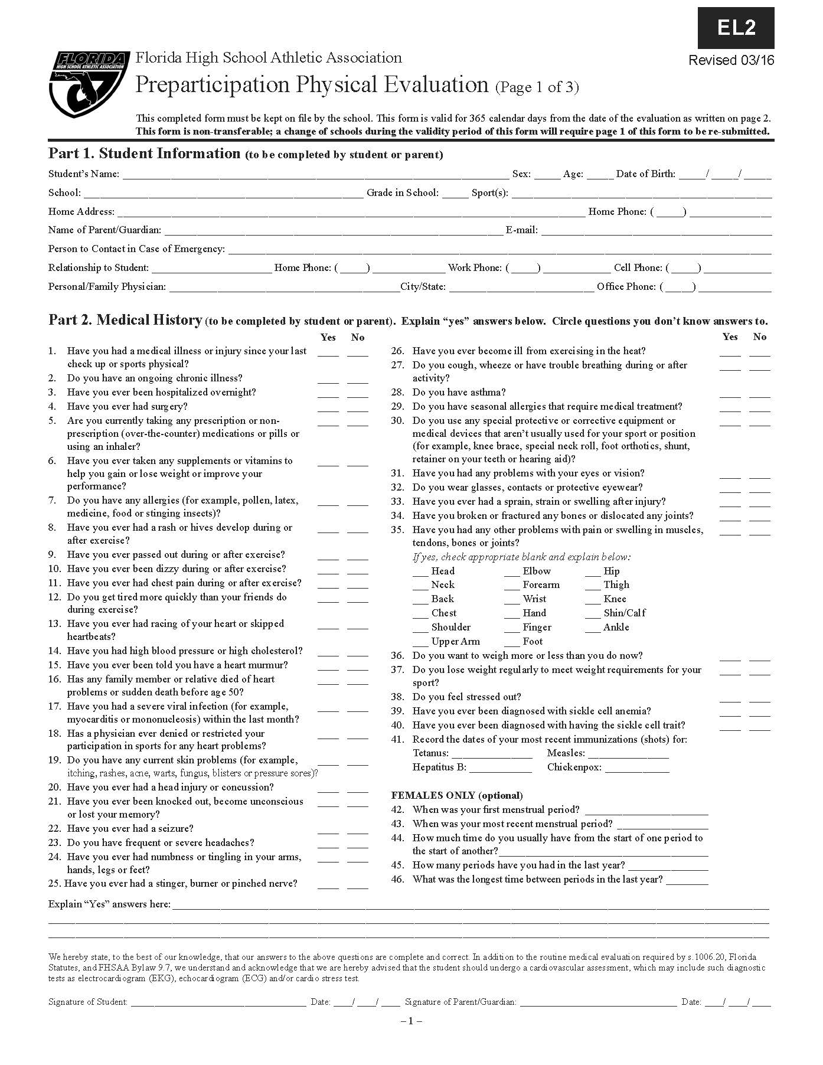

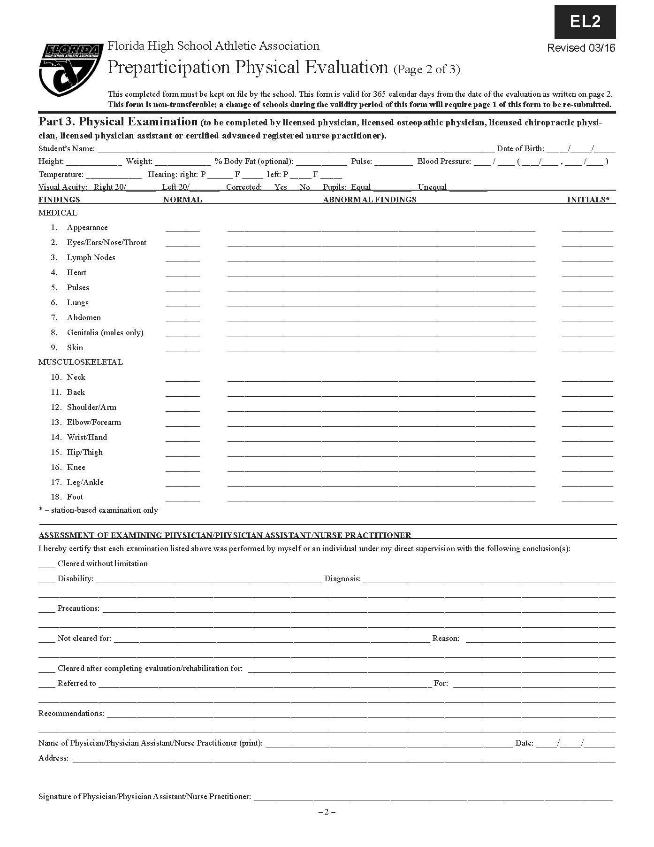

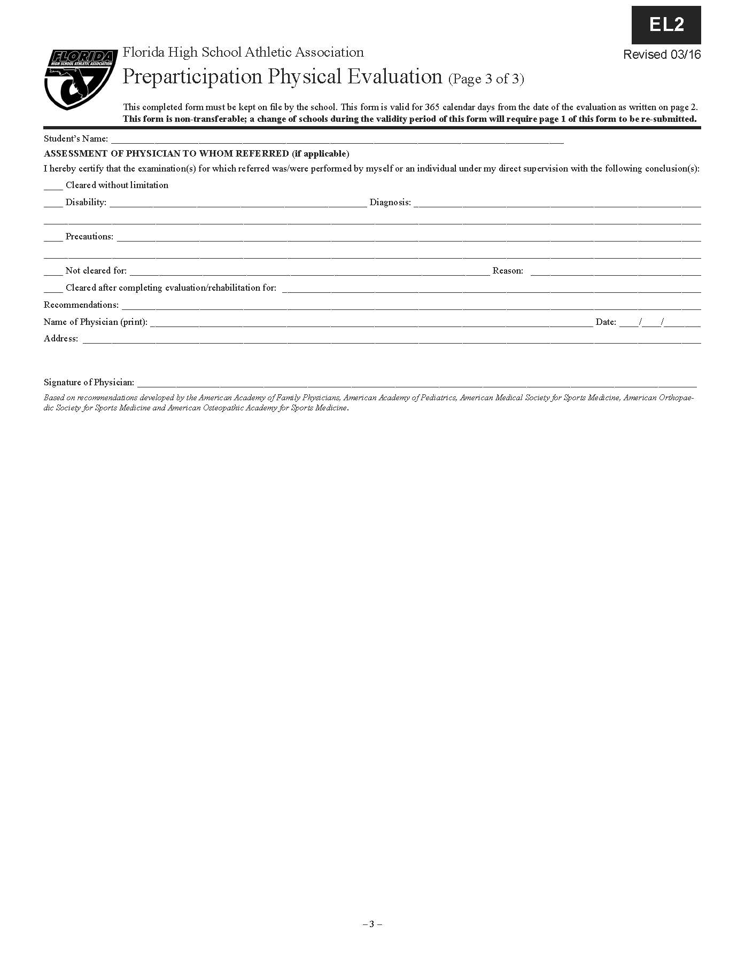

 



**2019-2020**

**Immaculata-La Salle High School**

**Student and Parent Verification and Code**

I, , grade _____ have read the above ILS Student-Athlete Handbook and understand what the expectations are of me as a member of the ILS student- athlete body. I agree to uphold and follow the policies described within and understand that any violation can and will result in actions by the coach, Athletic Director, Dean of Students, and/or the Principal.

**Student Signature: _____________________________________ Date: _____________**

As a parent of an athlete in this school, I promise:

* *To accompany my child to as many orientation and informational meetings offered by the*

*Athletic Department, as my schedule will permit.*

* *To work closely with all school personnel to ensure an appropriate academic as well as athletic experience for my child while he/she is in high school.*
* *To assure that my child will attend all scheduled practices and athletic contests. To require my child to abide by the Athletic Department’s training rules.*
* *To acknowledge the ultimate authority of the coach to determine strategy and player selection. To maintain positive cheering at all athletic contests.*
* *To promote mature behavior from students and parents during athletic contests.*
* *To work cooperatively with other parents and school personnel to ensure a wholesome and successful athletic program for our school.*
* *To work closely with coaches and other school personnel to identify a reasonable and realistic future for my child as a student athlete.*

*I acknowledge I have received and read the Immaculata-LaSalle High School Athletic Handbook.*

**Parent/Guardian Signature: ___________________________________ Date: ___________**

**Print Parent/Guardian Name: __________________________________**

**2019-2020**

**Immaculata-La Salle High School**

**Concussion Policies**

1. If a student/athlete sustains a blow or hit directly or indirectly to the head they are to be immediately referred to the school’s Certified Athletic Trainer.
2. If the Certified Athletic Trainer, based on his/her assessment, determines that the student/ athlete is experiencing or has experienced concussion symptoms regardless of how long it lasted, he/she is to immediately inform the parents of the student/athlete of the situation and instruct them on precautions and when it would be necessary to take their child to the hospital emergency room if needed. Also, instruct the parents on the School concussion procedures, as listed.
3. School is to abide by the orders prescribed by the medical doctor regarding the student’s academic duties.
4. If a concussion is deemed sustained to a student/athlete, he/she will be encouraged to be seen by a specialized medical Sports Concussion Team relative to the Sports Medicine Pediatric Concussion Guidelines, their prescription is to be strictly adhered to concerning the academic and athletic activities of the student/athlete. These guidelines have to adhere to four principles: pass a clinical evaluation by a MD or DO, number of consecutive asymptomatic days, number of physical asymptomatic exertion days, supervised by the school Certified Athletic Trainer and pass the Impact Post Injury Test, as revealed by the attending Physician.
5. If the student/athlete is seen by a MD or DO and is cleared to participate in sports without adhering to the above mentioned guidelines (no. 4 – four principles), the student athlete then has to adhere to 7 consecutives asymptomatic days, 3 exertional asymptomatic days, supervised by the school Certified Athletic Trainer and pass the post injury impact test, as assessed by University of Miami Concussion Center.